QUESTIONS
    - Where is the action of the play set? [p5]
    - With what news does the play begin? [6]
    - In what year is the play set? [p5]
    - When did the actual war that the play talks about, take place?
    - What are the ‘Balkans’?
    - Why does he use the descriptive words “not like anything to be seen in the West of Europe”? [p5]
    - What is a tea-gown? [p5]
    - Why is Catherin wearing her tea-gown all day long? [p5]
    - Where is “Slivnitza”? [p6]
    - What does the word ‘Serbs” refer to? [p6]
    - Who is “Byron”? [p7]
    - Why does the writer refer to ‘Byron’?
    - Who is “Pushkin”? [p7]
    - What is the meaning of the expression “ cut a poor figure”? [p7]
    - What does the “Tsar’s court” refer to? [p7]
    - Why does Raina use the word “prosaic” in “prosaic little coward”? [p7]
    - Who is Raina in love with? [p7]
    - What was Raina’s ideas about heroism and patriotism? [p6]
    - How were these ideas changed by the actions of Sergius? [p7]
    - Mention two humouristic incidents in the play.
    - How does the Russian Officer behave towards the women? [p11]
    - How does the Russian Officer behave towards the soldiers shooting from the street? [p12]
    - What does the difference in behaviour tell you about the Officer?
    - What does the following proverbs mean: “ A narrow shave”, “ a miss is as good as a mile”? [p12]
    - The man is a professional soldier. Why would a professional soldier fight in a war? [p12]
    - Why is it significant that the man mentions he has been under fire for three days? [p13]
    - Explain the idiom “never smelt powder before”. [p14]
    - Who is Don Quixote? [p15]
    - What is Bluntschli’s impression of the Calvary charge? [p15]
    - Why was the Calvary charge a suicide mission? [p15]
    - He compares Sergius to “flourishing like a drum major”. Explain this comparison. [p15]
    - Why does Shaw use the phrases “a hypnotized rabbit” and “nervous as a mouse”? [p17]
    - Raina is very proud of her surname and status. How does Bluntschli succeed in ridiculing this status? [p17]
    - Why is Bluntschli not impressed with the rank of Major? [p17]
    - Why does Raina want to shake hands with the man? What does it mean? [p18]
    - Why is it humourous that Bluntschli wants to wash his hands? [p18]
    - What is the difference in the way Raina and Catherine react to the dirty Bluntschli in bed?
    - What have you learned about Bluntschli’s background?
ARMS AND THE MAN (ACT 1)
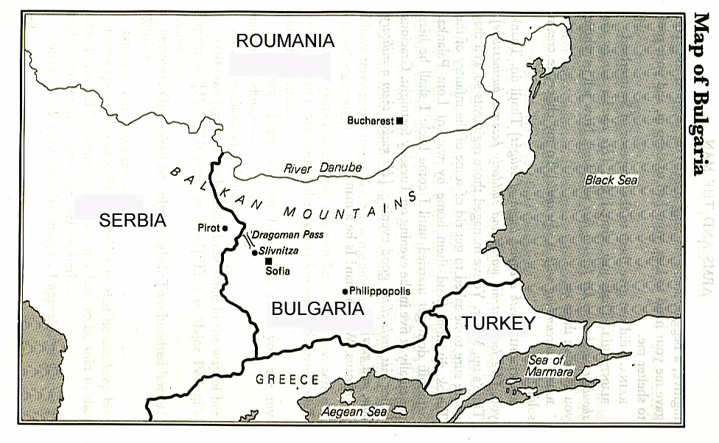
IMPORTANT BULLETS:
The play is set in the north-west corner of Bulgaria, near the pass through which the Serbian army had moved towards the capital, Sofia. Before they reached Sofia they were defeated at Slivnitza.
The action of the play begins with the news of this battle and the flight of the Serbian soldiers back through the ‘small town’ towards their own country Serbia.
The play is set in late November, 1885.
The actual war talked about in the play occurred less than ten years before the date of the production.
The Balkans is the Balkan mountain range, part of the chain runs just north of Sofia and the Dragoman. See the map. The mountains gave their name to this whole region of sout-eastern Europe which suffered from political instability in the late nineteenth and early twentieth centuries.
Shaw wants his English audience to get the feeling of a place which is remote from their own evironment as well as more beautiful - a traditional romantic setting.
Catherine reveals her desire to be always seen as a grand lady by wearing a tea-gown all day long. A tea-gown is a flowing and colourful dress worn by ladies on the days when afternoon teaparties used to be frequent social occasions.
During the 1800’s teaparties were used by society to mingle and introduce single males and females from the upper class to each other.
Slivnitza is a town in which the battle occurred. It is close to the Dragoman pass.
The Serbs come form the country Serbia. It is now part of Yogoslavia.
Raina did not believe in heroism and bravery.
Raina thought they all pretended socially that they were something they were not.
Raina refers to Byron, Lord George Gordon Byron, and English aristocrat and poet. He attacked everybody in his writing and refused to put up with social attitudes which he thought was false. He exiled himself from England.
The English audience would know Byron, and Shaw wants the audience to know that Raina is like Byron, she thinks their social behaviour is false.
Pushkin, Alexander Sergivich Pushkin, is a Russian writer who wrote the same as Byron about Russia and the behaviour of the Tsar and the upper class people of Russia.
Raina thought Sergius just pretended to be brave, and just dressed like a brave soldier. She is surprised to hear from Catherine that he actually behaved like a brave soldier. She is surprised to find out that upper class gentleman who become officers in the army, really fight and act brave.
The term “cut a poor figure (p.7)” means you compare unfavourably with someone else.
Raina was afraid that Sergius would compare poorly to the brave officers from the Tsar’s court, soldiers and officers from Russia who helped the Bulgarians.
Raina calls herself a ‘prosaic coward’. She does not believe in stories of bravery only in poetry of romance and love.
Raina is betrothed (engaged) to Sergius. She waited a year before she got engaged to him.
Raina is surprised and excited that Sergius is a true hero. This makes him a more romantic figure. The picture of a soldier she is in love with is real.
The man that enters Raina’s bedroom represents everything that is not heroic.
To accentuate his anti-heroic role, he enters the room in a shabby, torn uniform. He does not look like an officer and he does not act like an officer. He compares poorly to the picture of Sergius.
Bluntschli shows he is no gentlemen by taking Raina’s robe.
If Raina is found half dressed in the room with Bluntschli, her reputation would be spoiled. No man would ever marry her again.
It is humorous to see that Raina is more afraid of losing her reputation than she is of Bluntschli’s revolver. Shaw is making fun of the English’s sence of morality.
When Raina orders Bluntschli to hide behind the curtains it takes on the characteristics of a farce. It becomes a funny situations, characters act uncharacteristically.
The Russian officer that enters the room to search for the man shows that all officers have two personalities. The one personality is kind and well-behaved towards the ladies in the room, the other personality screams loud insults to the men in the street, using foul language. Shaw wants to show how people can pretend to be good, and how they change when confronted with different situations.
Shaw makes use of many proverbs e.g. “A narrow shave” which means a narrow escape, “a miss is as good as a mile” which means to have avoided danger by a narrow margin is as good as having avoided it by a large margin, since either way one remains unharmed.
Bluntschli explains he is a professional soldier. This means he is not loyal to Bulgaria or Serbia. He is from Switzerland and merely offered his services as officer to Serbia for money. He is not loyal to anybodies cause. Another word for professional soldier is mercenary. He fights for money and not for a patriotic cause.
Bluntschli mentions that he fills his pistol holster and cartridge holders with chocolates and grub. “Grub” is a slang expression for food.
Bluntschli mentions he has been under fire for three days. Shaw uses this because a veteran from the American Civil War testified that you became extremely nervous after being under fire for a few days. This refers to a new psychological state of that century.
Another idiom used is: “Never smelt powder before”. This idiom goes back to the days when the smell of gunpowder hung about a battlefield: the present equivalent is ‘never been under fire before’.
Bluntschli says Sergius looked like Don Quixote when he lead the calvary charge. Don Quixote is the main character in a novel written by Cervantes. Don Quixote is so overcome by romantic illusions that he imagines he is fighting an enemy when he is only attacking the sails of a windmill. Bluntschli says this because Sergius thought he was leading a great cavalry charge, but if the Serbs did not get the wrong ammunintion, Sergius and all his men would have been killed.
The Calvary charge was therefore a suicide mission and the person who lead it was either a fool or he had not control over his horse.
Sergius and his men charged the cannons and machine guns of the Serbs on horseback. If the Serbs had the right ammunition all of them would have been killed.
Bluntschli says Sergius looked like a flourishing drum major. A drum major plays the drums in a band and usually would throw his batons around above his head as he is hitting the drums.
Bluntschli is so tired that Shaw compares him to a ‘hypnotised rabbit’ and as ‘nervous as a mouse’. Rabbits are often thought to be mezmerized into inaction when confronted by danger or by their natural enemies. His rundown condition and nervousness is the same as that of a ‘nervous mouse’.
Raina wants to show Bluntschli that he did not just run into any house, but he ran into the most important house in town. She points out that their surname is Petkoff. Bluntschli, who comes from Switzerland, will not know this name or how important Raina is. He mocks her by innocently when he does not hear her surname correctly.
Raina also mentions the rank of her father. He is a major in the Bulgarian army. Bluntschi, who is familiar with war, knows that the rank of major is not that high and important. It is inferior to colonel, general and field-marshall.
Raina makes a promise that she will make sure Bluntschli survives. She wants to shake his hands because in romance, when you shake hands it is taken as one’s word of honour or a token of solemn agreement which was binding.
Bluntschli seems to have no idea of these romantic traditions and state that he must wash his hands first before they can shake hands. With this statement Shaw is making fun of taking baths and washing. In the 1800’s the Bulgarians thought that having clean air and clean clothes, made them much cleaner than the British with their filthy air. The Bulgarians only adopted the washing habits of big Western cities as pure ceremonies of culture and civilization, and not on hygienic grounds.
Raina sees Bluntschli’s human qualities and has tender feelings for him. Catherine only sees a dirty soldier in a clean bed and thinks of how she will get those sheets clean again. She has no feelings for the soldier. Both women however think it is romantic to have a fugitive in the house.

